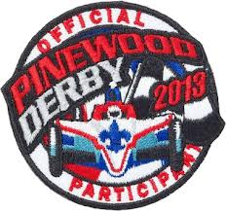
2015 Catawba District
Pinewood Derby

Saturday, April 18th
Clayton Homes Lancaster
Steven Truesdale
Cost: $5

Each Pack may register the top 6 scouts in overall speed within their unit.
After Scouts Race we will have time for Sibling/Adult race at no cost.
Registration deadline is April 17th. All Scouts MUST be PRE-REGISTERED and provided the requested info listed below.
All cars will be inspected and weighed per District Derby Rules. Sign in for all racers end at 10:45 – NO LATE arrivals can be entered in the race.
Check in: 9:00 – 9:45 Race Time: 10:00
The race normally last about 1-2 hours with 30 cars. We will not know how many cars we have until race day.
There will not be any seating so you need a chair. There will be prizes for the top 3 winners and 2 show cars.

Information is online next week with rules
Instructions:
- Fill out this form
- To register:
Email this form to Morgan Hawkins @ mhawkins@bsamail.org or mail the form
Council Office
420 S. Church Street
Spartanburg 29306
- Each Pack should have a form
- Other Scouts and spectators will be allowed to race after the official race. If possibly bring an extra car labeled with your name you don’t mind spectators touching to race with.
Scout’s Name | Unit # | Car Name
1.
2.
3.
4.
5.
6.
Scouts Participating in Pinewood Derby

