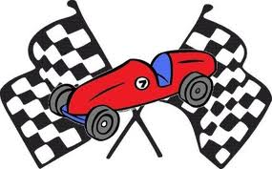
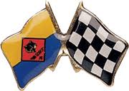
VROOM!!
VROOM!!
READY
SET
GO!!

CATAWBA DISTRICT
2015 OFFICIAL
PINEWOOD DERBY
EVENT RULES AND PROCEDURES

Scouts should be in complete uniform during the Derby!

SPECIAL NOTES TO ALL CONCERNED

This project is a parent and son event, and is recommended as such by the National Boy Scouts of America. The Activity Committee STRONGLY SUGGESTS that each parent emphasize this idea with your son. In all of the events, we require that the cars be built since last year's Pack Pinewood Derby.

Sportsmanship:
Two things the Pinewood Derby requires each participant to learn are 1) the craft skills necessary to build a car, and 2) the rules that must be followed. Even more important, though, is how we act and behave while participating in the Pinewood Derby or any other group activity. This is called sportsmanship. The first thing to remember about sportsmanship is that everyone's skills are a little different. You may be good at something like singing or drawing, but not as good at something else like basketball or computers. Parents have different skill levels, too. This doesn't mean that you are a good person one time and not good another time. You can always be a good person, whether or not you have good car-building skills. Remember, you and your friends are individuals first and racers second. This idea is often called having respect for others. The second thing to remember is to follow the rules. Without rules, there would be no Pinewood Derby. You will never know if you are really good at doing something unless you follow the rules. This is often called being honest. The third thing to remember about good sportsmanship is that there are winners and losers in every competition. You accept this when you choose to compete. There may be times when you win and feel happy, and times when you lose and feel unhappy. Being a winner is easy, and losing is sometimes hard. If you win, you must not brag or gloat. If you lose, you must not feel jealous or bitter. To be a good sportsman, you must be able to say "I did my best" and be satisfied with the results. You must also be able to appreciate and feel happy for someone else when they run a good race or build a neat car.

I. GENERAL RULES: (Applies to all Race Events)

G-1. Qualification: Cub Scouts who finished in the TOP 6 in overall speed with their Pack 2013 Pinewood Derby may participate.

G-2. Essential Materials: All cars entered shall be constructed from the "Cub Scout Grand Prix Pinewood Derby Kit” as sold in the Spartanburg and Charlotte BSA Scout Store. (Referred to below as “The Kit”).

G-3. Attendance: The Cub Scout must enter his own car. This means that the Cub Scout must be present at "Inspection and Registration" (G-6) to enter his car into competition, except for extenuating circumstances. Activity Chairman has the final call on this.

G-4. "New Work": The car entered will be the same car that participated and won in the Pack overall speed category.

G-5. Single Entry per Person: Only one car may be registered by any person in the Pinewood Derby.

G-6. Inspection and Registration: Each car must pass a technical inspection before it may compete. Technical inspection and registration of cars occurs on the morning of the race. All cars must be inspected and weighed in during the inspection and registration period. Times and dates will be announced by Catawba District.

G-7. Late Registration and Inspection: All cars must be inspected and weighed in on race morning during the times listed in G-6. Cars MAY NOT be registered after this time.

G-8. Failure to Pass Inspection: The Inspection Committee shall disqualify cars which do not meet the rules as described herein. If a car does not pass inspection, the owner will be informed of the reason his car did not pass. Cars which fail the initial inspection may be modified and re-inspected during the Inspection and Registration period (G-6).

G-9. Impound: No car may be altered in any way after it has been registered. After a car passes registration, it will be stored by the Pinewood Derby Race Committee until the races.

G-10. Car Design Rules Interpretation: Interpretation of the rules described in G1 through G-11, and T-1 thru T-9 are at the sole discretion of the Inspection Committee Judges present during the Registration and Inspection process.

G-11. Race-Day Rules Interpretation: On Race-Day, the Cub Scout must make all questions of rules interpretations and procedures to the Activity Chair or Race Officials promptly. Decisions of Race Officials on questions of rules interpretations and procedure may be appealed to the Activity Chair. All decisions of the Activity Chair are final. Decisions of Race Officials on questions of fact (i.e. the result of a specific race) may not be appealed beyond the Trackmaster. Note: Unsportsmanlike conduct by any participant or spectator will be grounds for expulsion from
the competition and/or the race area

II. CUB SCOUT RACE CAR DESIGN STANDARDS

T-1. Material: Race cars shall be constructed for this event from the parts contained in the Official Grand Prix Pinewood Derby Kit (referred to below as the kit) as sold by the Scout Shop in Spartanburg or Charlotte. Materials from the kit may be supplemented but not replaced. (See rule T-3)

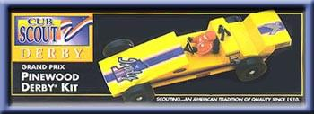 “The Kit” (some boxes slightly different)

T-2. Weight: Race cars may weigh no more than five (5) ounces (total weight) as determined on the official scales during the pre-race check-in.

T-3. Wheels and Axles: The car shall roll on the wheels from the kit. The wheels shall turn about the axle nails from the kit. The axle nails shall be firmly affixed to the wood of the car body, and MUST be placed in the original 'axle grooves' in the wooden block from the kit. It must be obvious to the judges that the grooves, wheels, and the nails from the kit are being used. Scouts may elect to purchase wheels from the BSA Scout Shop that are IDENTICAL to the kit wheels, but of a different color. These wheels will be allowed, but are subject to all rules of section T-6 and will be compared to a kit wheel at inspection time. If, in the opinion of the Inspector and/or Derby Chairman, the wheels are not identical to the kit wheels construction, the car will not be allowed to race.

T-4. Size: Race cars may be no longer than 7 inches, nor wider than 2-3/4 (2.75) inches, as determined by the official gages during the Registration and Inspection. Underside clearance of at least 3/8 (0.375) inches and inside wheel to wheel clearance of at least 1-3/4 (1.75) inches is recommended, so that the car will run on the race track. Adequate clearance is the responsibility of the race car builder. Car must also pass under the timing tower. 3 Inch height maximum is recommended.

T-5. Weights and Attachment: Weight may be added to the car and will be considered part of the car for purposes of all measurements. "Weight" is considered to be any material on the car that is not provided in the kit. All weight must be securely fastened to the car, e.g. by permanent glue, nails or screws, but not by "sticky substances", e.g. tape, or tack spray. Weights shall be passive, i.e. non-moveable, non-magnetic, non-electric, non-sticky, etc.

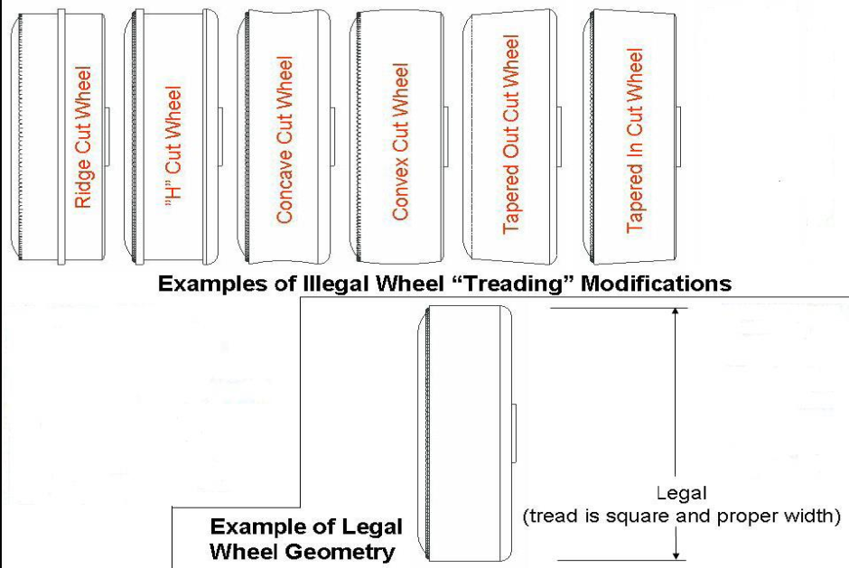
T-6. Wheel Treatment: Wheel treatment (hub and tread smoothing and polishing) may not result in substantial removal of mass or in reducing the wheel width from the original kit wheels. Some of the original "tread marks" on the wheel face must remain intact, i.e. apparent to the inspector (see pictures below). Wheels may not be machined to a beveled condition and the portion of the wheel surface that contacts the track must remain parallel to the axle (see picture below).

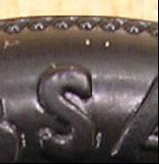
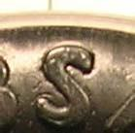
Illegal wheel (tread Legal wheel (tread
marks are gone) marks intact)

T-7. Unacceptable Construction: The following may NOT be used in conjunction with the wheels or axles: washers, inserts, sleeves, bearings. If hubcaps are used, axle nail head must remain uncovered.

T-8. Gravity Powered: The race car may not be constructed or treated in such a way that the track's starting mechanism imparts momentum to the car. (For instance, this provision disqualifies cars with sticky substances on the front of the car or protrusions which may catch on the starting pin.)

T-9. Lubricants: Dry lubricants such as graphite will be allowed for lubricating the wheels. Do not over apply lubricant. Use lubricants sparingly, as lubricants may not foul the track. Any car whose lube fouls the track will be subject to expulsion. All lubrication must be done prior to check-in and must be done at specified locations.

III. CONDUCT OF THE RACES

Competition will consist of heat races. Track officials are responsible for the proper conduct of the races.

C-1. Inspection Gages: The race-day "Pit Stop" area will have the official scale and length box. That check-in equipment will be the official equipment for the race. (The same 5 oz. Master Weight used for scale calibration will also be available on race day. Please stress this fact to all Cub Scouts. They should be prepared to make adjustments to their cars if necessary.)

C-2. Race Day Lubrication: There will be NO lubrication done after the car passes through inspection and registration (G-6).

C-3. Car Handling Responsibility: Scouts shall be responsible to present their own cars at the starting line for staging. Cars will be staged on the tracks by the "Starter Team." If, in the opinion of the Trackmaster, a scout's physical limitations prevent him from fully complying with this requirement, the scout may nominate an assistant of approximately the same age who serves subject to approval of the track chairman. In any case, the scout shall participate up to his limitations.

C-4. Lane Assignment: To equalize differences among track lanes, each car will race once in each lane. After all cars have run once in each lane, average times will be used to determine the fastest cars, with each scout’s slowest run thrown out. Individual car averages will be used to determine finishing order, with each scout’s slowest run thrown out.

C-5. Car Leaves Lane: If, during a race heat, a car leaves its lane, the race will be re-staged and re-run. If the same car again leaves its lane the car that leaves the lane will take a 9.999 time for that heat.

C-6. Car Repair (Without Fault): If, during the race, a wheel falls off or the car becomes otherwise damaged, then the scout may, to the best of his ability perform repairs with the assistance of his adult partner or Pit Crewmember, under the supervision of the Trackmaster. The scout is allowed three minutes to fix the car. The car must meet all rules standards. The Officials will run the heat again. If the car cannot be fixed in three minutes, it loses the heat, and will be assigned a time of 9.99 seconds.

C-7 Car Repair (With Fault): If a car is damaged due to track fault, or damage caused by another car or person, then the Trackmaster, at his sole discretion, may allow additional repair assistance to the Cub.

C-8. No Finishers: If, during a race heat, no car reaches the finish line on the track, all cars will be assigned a time of 9.99 seconds.

C-9. Call to Race: Competitors will be called by name prior to each heat. When his name is called, the scout will be given his car from "the stage". He will then present himself, with his car, to the "Pit" area for the next race. If the Cub does not respond, his name will be called a second and third time. If the Cub has not presented himself in time for his heat, he will be assigned a finishing time of 9.99 seconds for that race heat. If no competitor present, the Derby Chairman may, at his sole discretion, defer the race heat in a manner that does not interfere with progress of the racing.

C-10. Track Repairs: If a car leaves its lane, at his sole discretion, the Trackmaster may inspect the track and, if a track fault is found which probably caused the initial violation, the Trackmaster may order the race heat to be rerun after the track is repaired.

C-11. The Race Area: Only race officials may enter the pit area. This rule will be strictly enforced.

The track and score board will be run by Bobby Bass. For any questions or concerns about these rules please contact Dee Grooms. She will get the Pinewood Derby Committee together and discuss your concern. Once they have come up with the answer you will be notified.

Dee Grooms wdgrooms@gmail.com 803-374-4435

