BALOO Training
Advanced training for Cub Scout leaders
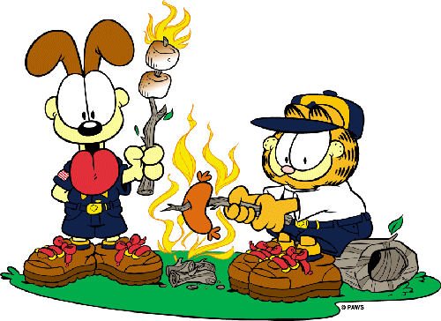
Date: November 8, 2014
Place: Westminster Park
3916 India Hook Road
Rock Hill, SC 29732

- Check-in 8:00am-8:30am
- Opening Ceremony 8:45am
- Closing Ceremony 4:30pm
Lunch will be available for purchase
Cost: $10 / participant
Registration Deadline: October 28, 2014
To register: send the form below with a $10 check payable
to Palmetto Council, BSA to:

Morgan Hawkins
Palmetto Council, BSA
420 S. Church Street
Spartanburg, SC 29306

For more information please contact:
Donna Fletcher
dbfletcher55@gmail.com
2014 York District BALOO Registration Form – send to council office with $5 registration fee (instructions above)
Name: ____________________________________________________________________________________________
Unit: ___________________
Position: _______________________________________________
Address: _________________________________________________________________________________________
Phone (s): _________________________________________________________________________________________
Email: ______________________________________________________________________________
2014 BALOO Course Schedule
8:00 - 8:45 Registration/gathering activity 12:15 - 1:00 Campfire
8:45 - 9:00 Opening Assembly 1:00 - 1:30 Health and Safety
9:00 - 9:30 Aims and Purposes 1:30 - 2:00 Program
9:30 - 10: 15 Planning 2:15 - 2:30 Round Robin Intro
10:30 - 11:00 Lunch Prep (Foil Packs) 2:30 - 2:45 Round Robin Session 1 - Fire Safety
11:00 - 11:30 Equipment 2:50 - 3:05 Round Robin Session 2 - First Aid & Sanitation
11:30 - 12:00 Lunch 3:10 - 3:25 Round Robin Session 3 - Hikes & Games
12:00 - 12:15 Campfire Planning 3:30 - 3:45 Round Robin Session 4 - Cub Scout Cooking
4:00 - 4:30 Recognition and Closing

